Hurricane Back-Casting

<https://coast.noaa.gov/hurricanes/>

Accessed 9/9/2019

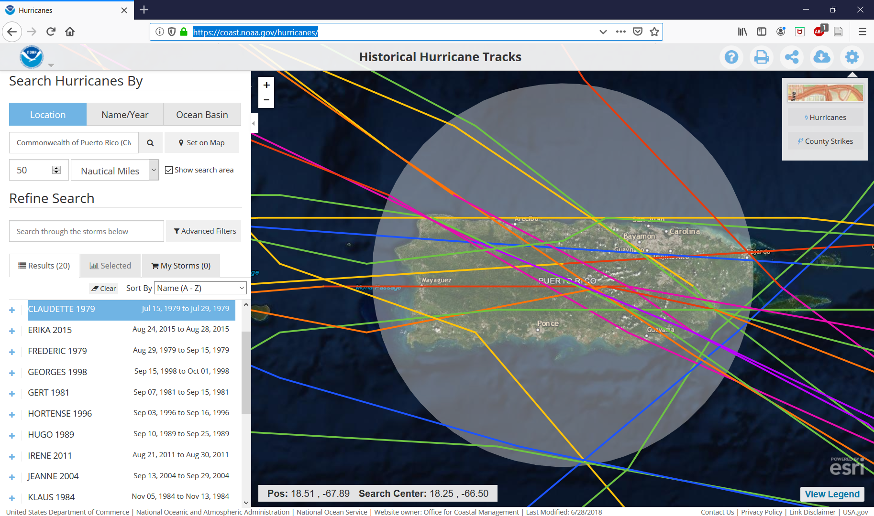

<https://www.nhc.noaa.gov/aboutsshws.php>

